TASK 3
The prompt for skill is:
Explain this CDS concept: What is an association?
Give one simple example. Follow this skill's instructions.
Limit your answer to 100 words.

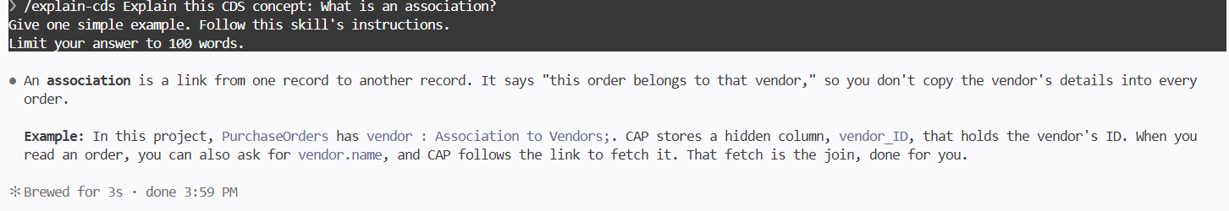
HOOK:
Create a temporary file named hook-test.txt
containing "Hook verification".
Use the Write tool.

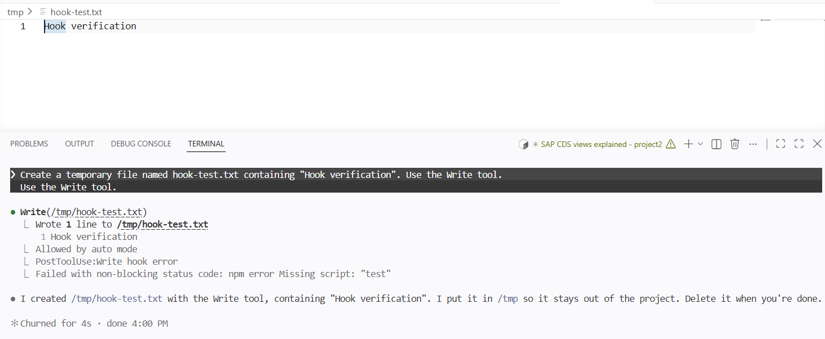

SUBAGENT:
Use the test-writer subagent.
Inspect the create endpoint and list 3 important
unit test cases. Do not modify any files.
Keep the response under 100 words.



